2017 WATS Summer Camping Event – Cornet Bay Retreat Centre
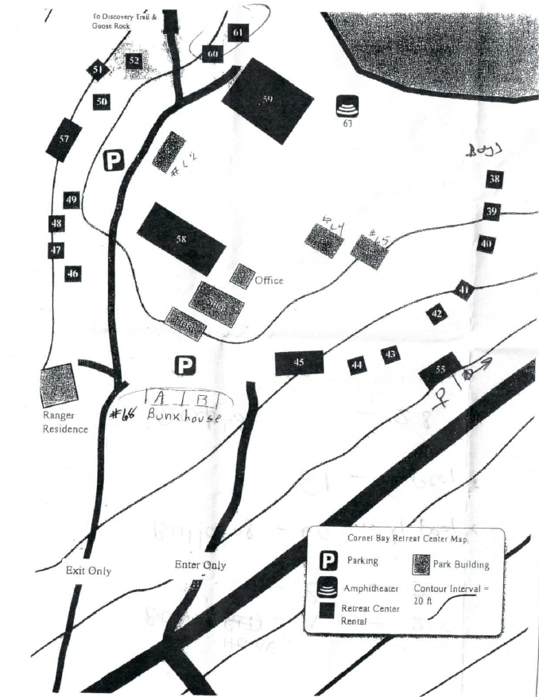
Location: Cornet Bay Retreat Center at Deception Pass State Park
Check In: July-21st – 2:00pm; Check Out: July-23rd – 11:00am
Park Address: 400 Cornet Bay Road, Oak Harbor, WA 98277 (use this address in GPS and Google Maps for driving directions)
GPS Location (Park Entrance): Latitude: 48.394303; Longitude: -122.639541
Directions from Redmond/Bellevue/Issaquah:
Take I-405N & I-5N, follow the below directions
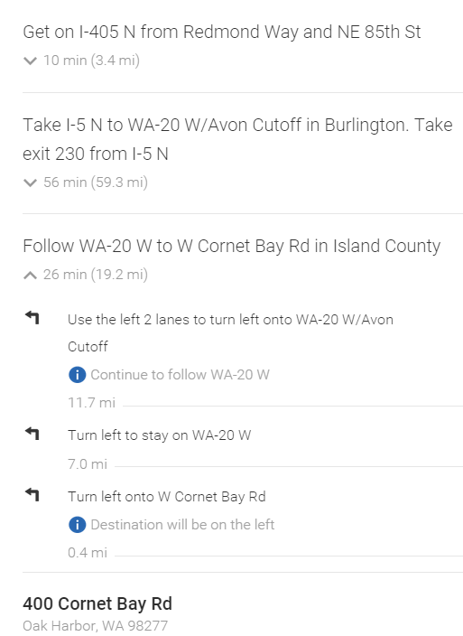
Park Web page: http://parks.state.wa.us/362/Cornet-Bay
Park Ranger Tel# (360) 679-2482
Nearest Hospital for Emergency Care:
Whidbey General Hospital, 101 N Main St, Coupeville, WA 98239 Tel# (360) 678-5151
Route from camping site to Whidbey General Hospital (~30 mins):
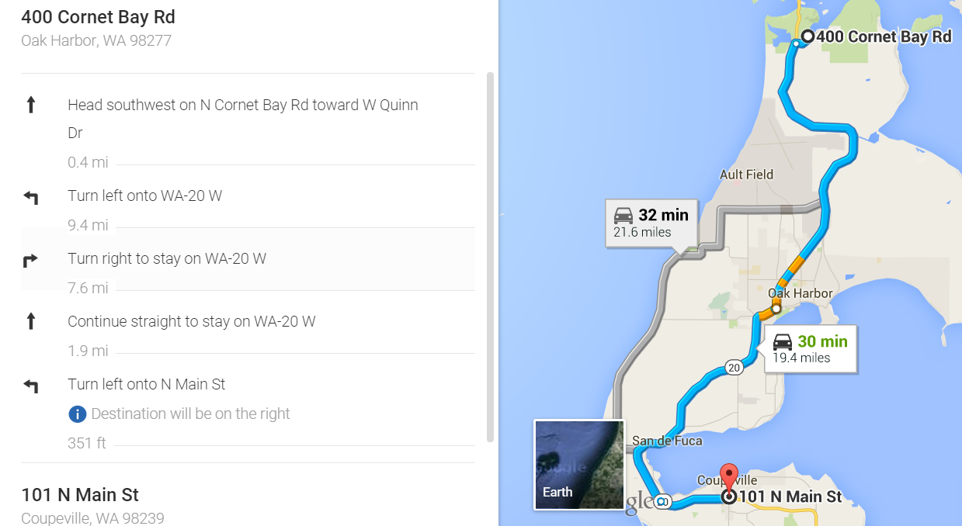
Island Hospital, 1211 24th St, Anacortes, WA 98221 Tel# (360) 299-1300
Route from camping site to Whidbey General Hospital (~20 mins):
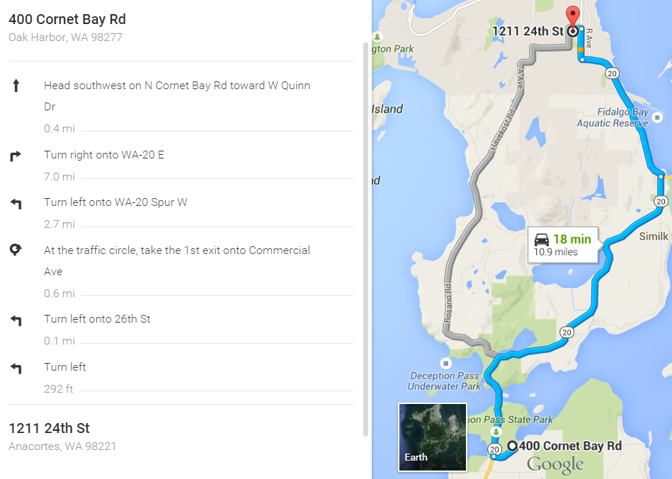
Parking and site Map: Please park on the highlighted assigned spots, more additional parking is available at Deception Pass State Park (Free park passes are available at the camp office)
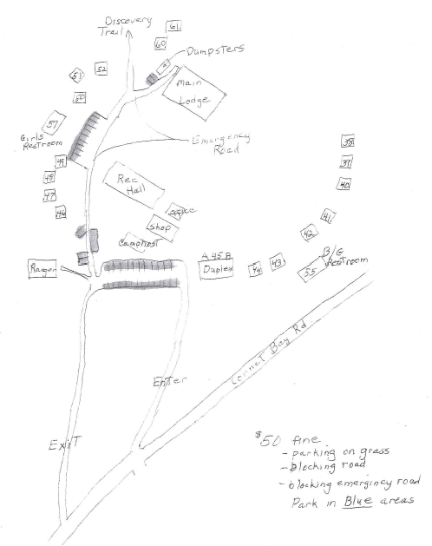
Common area:
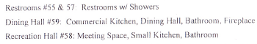
WATS Board Contacts Tel# for any Questions:
Ram K: 425-281-4457; Anu: 425-503-9361; Ram P: 425-999-9116
Anil: 425-449-3030; Shakil: 425-212-8876; Kalyan: 425-394-3634
Srini: 425-985-2035;
Dining Hall: Food Serving Times
- July-21st: Snack: 3:00pm, Dinner : 7:00pm
- July-22nd: Breakfast: 7:00am, Lunch:12:00noon, Snack: 3:00pm, Dinner : 7:00pm
- July-23rd: Breakfast: 6:30am, Lunch:11:00am (To Go Boxes only)
Note: Please bring any special dietary needs for your kids and family members.
Grocery Store: Walmart (Open 24Hrs), 1250 Southwest Erie Street, Oak Harbor, WA 98277
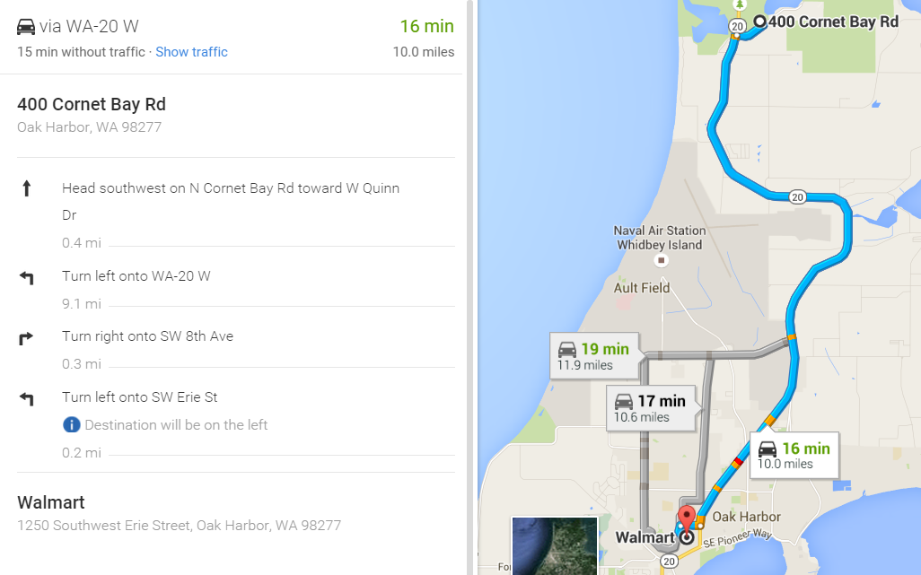
Items To Bring:
- Linens – Bed sheets, Pillows, Pillow Covers, Blankets, Comforters, Towels.
- Personal Items - Soaps, Shampoos, Tooth Paste, Tooth brushes, combs, Body Lotions and other items etc.
- Warm clothes (Jackets, Sweaters etc.) to stay comfortable in the evening’s night and early morning, Hats, Caps, Sun glasses
- Infant and baby food, medicines are parent’s responsibility.
- Electrical/Electronic Items: Cell Phone chargers, Extension Chords etc. to charge your devices. ( Note: The cellular reception is very weak and Wi-Fi is available at limited area at Camping site)
- Lotions: Sun Screen Lotions ( Adults & Kids ), Insect/Mosquito Repellent,
- Personal Medicines, First Aid Kit, Flash Lights, Torch Lights, etc.
- Optional Items: Tent, Kids Toys, Bikes or any other play items (soccer/Volley Balls, Kites etc.)
Items not to Bring:
- Pets are strictly not allowed inside the camp site.
- Any type of Fire Crackers.
- Fire Arms and any dangerous combustible items
- Motor Homes, RV, Boats etc.
- Electrical Appliances: TV, Electric Skillets, Toasters, Electric Heaters & Electric Blankets etc.

